**MIC testing of extracts – Using a lux tagged bacterium**

**Abstract:**

This protocol details how to perform a minimum inhibitory concentration test with fungal extracts against a single bacterium.

**Keywords:**

96-well plate, pipette, serial dilution, luminescence, multichannel, extract

**Guidelines:**

None

**Before start:**

Make sure you have an overnight culture of your bacteria you want to test. These bacteria must be lux-tagged for this protocol.

Dissolve the received extracts in 50 mg/mL DMSO (Dimethyl sulfoxide) to work out what volume to use the mass of the extract (grams) and divide it by 50 mg/mL to get volume of DMSO to add to each vial. I.e. v = m / c (volume will be in mL)

Dissolve the extract completely so that no particles remain. Use the vortex and centrifuge to achieve this.

Find out the MIC of your chosen bacterium to your chosen antibiotic that is to be used as a positive control. An approximation is good enough – you want the range of dilutions to encompass a range of inhibitory and non-inhibitory concentrations.

**Safety Warnings:**

It is unknown what compounds are in the extracts and some may contain toxic or carcinogenic chemicals, make sure you wear gloves when handling them.

**Specialised equipment:**

* Benchtop centrifuge
* Spectrophotometer
* Victor plate reader

**Materials:**

* An overnight culture of chosen bacteria.
* Black flat-bottomed 96-well plates, one per extract and one as a control plate.
* Pipettes and multichannel pipettes
* Extracts to test and the five fractions and the crude extract
* Mueller-Hinton broth (roughly 50 mL is sufficient for one test plate and one control plate.
* A spare Petri-dish or pipetting trough.
* Clean MHA plates (at least 2)
* A stock solution of antibiotic to be used as a positive control in your control plate. Rifampicin can be used for Gram-positive organisms and mycobacteria. Erythromycin can be used for Gram-negative organisms.

**Steps:**

**Setting up your plate:**

1. Set up your plate according to Figure 1. Use masking tape to make a front label on the lid including your name or initials, the date, the name of the bacteria you are testing against, and the name of the extract you are testing.
2. The final volume you will be using in each well is 100 µL. Therefore add 50 µL of Mueller Hinton Broth (MHB) to all of the wells on the first plate except the top row (A).
3. The final extract concentration is 1 mg/mL (but this can be altered to meet other requirements if necessary).
4. To meet this concentration (if the extract was dissolved in 50 mg/mL) add 96 µL MHB to all the top row of wells and 4 µL of each extract to the 96 µL MHB. Mix well and change tips between fractions.   
   *If you dissolved it in 100 mg/mL then work out the correct amount accordingly:   
   C1 x V1 = C2 x V2  
   50 mg/mL x  mL = 2 mg/mL x 0.1 mL  
    = 0.004 mL
5. Using a multichannel pipette, aspirate repeatedly to homogenise the extract solution.
6. Using a multichannel pipette transfer 50 µL from the first row to the second row and aspirate to mix. Discard tips and repeat the doubling dilution down the plate, changing tips between rows, until you reach row G. Do not continue the dilution into row H.
7. Aspirate 50 µL from the wells in row G and discard the solution. This will leave = row H as a growth control containing no extract.

**Control plate:**

1. To set up your control plate dilute your DMSO to the same concentration as the extract. i.e. 96 µL and 4 µL DMSO in the top well and the one adjacent to it.
2. Dilute your antibiotic (positive control) to a suitable concentration usually 5x the MIC. I used Erythromycin at a max concentration of 1 mg/mL.
3. Add 100 µL of MHB to the final two columns as a negative sterile broth control.
4. Repeat the same doubling dilution process as before, again leaving row H as a sterile broth control.

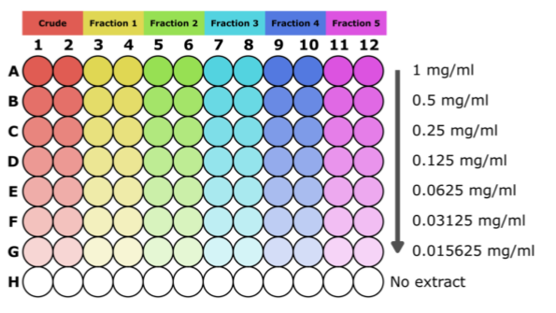

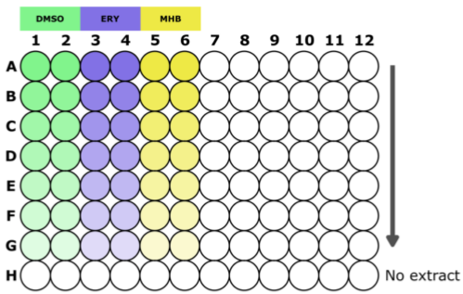

Figure 1: Plate setup of extracts for minimum inhibitory concentration.

**Adding your bacteria:**

1. Dilute your bacteria 1:10 in a 1.5 mL cuvette with MHB (720 µL broth + 80 µL bacteria).
2. You need to again dilute this bacteria to an OD600 of 0.001 equivalent to ~106 bacteria. You can do this by diluting your bacteria to an OD600 of 0.01 and then diluting that 1 in 10 to 0.001.
3. Calculate the volume of bacteria you need for your test plate and control plate, you will need 50uL in all wells to get to 100 µL total volume. So calculate your total wells and multiply by 50 µL e.g. 128 wells x 50 µL = 6400 µL or 6.4 mL (V2) Add extra to account for pipetting errors and to check the CFU of your inoculum.
4. Make up your bacteria and broth combination in a 50 mL Falcon tube using a serological pipette for broth (either 10 mL of 25 mL).
5. Tip your bacteria into a Petri-dish and use a multichannel to add 50 µL to all the wells excluding the MHB sterile control.

**Check your CFU:**

1. With remaining bacteria from your falcon tube and remaining space in the control plate dilute the bacteria 1:10 and add 90 µL of MHB or Phosphate Buffer Solution (PBS) to each of the wells in a single column (roughly 6-8 should be plenty). Mix in 10 µL of bacteria to the top well and perform a serial dilution down the plate (doubling dilutions)
2. Use a multichannel pipette to take 10 µL from those wells onto another clean agar plate. Do at least three technical replicates and leave to dry before incubating upside down in the standing incubator overnight.
3. Perform colony counts the next day to ensure you had a correct inoculum, roughly 106

**Measuring your bacteria:**

1. Take a time 0 (T0) measurement of your bacteria in the Victor plate reader.
2. Log in to the computer and double click the Victor program on the desktop. Ensure that the plate setup to set to 96-well plate bioluminescence.
3. Place your plate in the machine without the lid and click run
4. Once your plate has run save the data (from computer, recent) to your own document with the date, fungi ICMP number, extract name, time point and initials (YYYY-MM-DD_17554_MC10-103_T0_SV) If it’s the control plate then name it the same except with ‘control’ added.
5. Complete more measurements at T2, T4, T8 (if you can) and T24.
6. If your extract is active (luminescence reduction) and reduced the light to background levels then plate out 10 µL from those wells onto fresh MHA plates to check bactericidal ability.